HTML Elements

The HTML **element** is everything from the start tag to the end tag:

<tagname>Content goes here...</tagname>

Examples of some HTML elements:

<h1>My First Heading</h1>

<p>My first paragraph.</p>

|  |  |  |
| --- | --- | --- |
| **Start tag** | **Element content** | **End tag** |
| <h1> | My First Heading | </h1> |
| <p> | My first paragraph. | </p> |
| <br> | *none* | *none* |

## HTML Headings

HTML headings are defined with the <h1> to <h6> tags.

<h1> defines the most important heading. <h6> defines the least important heading.

### **Example**

<h1>Heading 1</h1>  
<h2>Heading 2</h2>  
<h3>Heading 3</h3>  
<h4>Heading 4</h4>  
<h5>Heading 5</h5>  
<h6>Heading 6</h6>

## HTML Paragraphs

The HTML <p> element defines a paragraph.

A paragraph always starts on a new line, and browsers automatically add some white space (a margin) before and after a paragraph.

### **Example**

<p>This is a paragraph.</p>  
<p>This is another paragraph.</p>

## HTML Horizontal Rules

The <hr> tag defines a thematic break in an HTML page, and is most often displayed as a horizontal rule.

The <hr> element is used to separate content (or define a change) in an HTML page:

### **Example**

<h1>This is heading 1</h1>  
<p>This is some text.</p>  
<hr>  
<h2>This is heading 2</h2>  
<p>This is some other text.</p>  
<hr>

## HTML Line Breaks

The HTML <br> element defines a line break.

Use <br> if you want a line break (a new line) without starting a new paragraph:

## The HTML <pre> Element

The HTML <pre> element defines preformatted text.

The text inside a <pre> element is displayed in a fixed-width font (usually Courier), and it preserves both spaces and line breaks:

### **Example**

<pre>  
  My Bonnie lies over the ocean.  
  
  My Bonnie lies over the sea.  
  
  My Bonnie lies over the ocean.  
  
  Oh, bring back my Bonnie to me.  
</pre>

## HTML Formatting Elements

Formatting elements were designed to display special types of text:

* <b> - Bold text
* <strong> - Important text
* <i> - Italic text
* <em> - Emphasized text
* <mark> - Marked text
* <small> - Smaller text
* <del> - Deleted text
* <ins> - Inserted text
* <sub> - Subscript text
* <sup> - Superscript text

## HTML <b> and <strong> Elements

The HTML <b> element defines bold text, without any extra importance.

### **Example**

<b>This text is bold</b>

The HTML <strong> element defines text with strong importance. The content inside is typically displayed in bold.

### **Example**

<strong>This text is important!</strong>

## HTML <i> and <em> Elements

The HTML <i> element defines a part of text in an alternate voice or mood. The content inside is typically displayed in italic.

**Tip:** The <i> tag is often used to indicate a technical term, a phrase from another language, a thought, a ship name, etc.

### **Example**

<i>This text is italic</i>

The HTML <em> element defines emphasized text. The content inside is typically displayed in italic.

**Tip:** A screen reader will pronounce the words in <em> with an emphasis, using verbal stress.

### **Example**

<em>This text is emphasized</em>

## HTML <small> Element

The HTML <small> element defines smaller text:

### **Example**

<small>This is some smaller text.</small>

# **HTML Quotation and Citation Elements**

In this chapter we will go through the <blockquote>,<q>, <abbr>, <address>, <cite>, and <bdo> HTML elements.

### **Example**

Here is a quote from WWF's website:

For 60 years, WWF has worked to help people and nature thrive. As the world's leading conservation organization, WWF works in nearly 100 countries. At every level, we collaborate with people around the world to develop and deliver innovative solutions that protect communities, wildlife, and the places in which they live.

## HTML <blockquote> for Quotations

The HTML <blockquote> element defines a section that is quoted from another source.

Browsers usually indent <blockquote> elements.

### **Example**

<p>Here is a quote from WWF's website:</p>  
<blockquote cite="http://www.worldwildlife.org/who/index.html">  
For 60 years, WWF has worked to help people and nature thrive. As the world's leading conservation organization, WWF works in nearly 100 countries. At every level, we collaborate with people around the world to develop and deliver innovative solutions that protect communities, wildlife, and the places in which they live.  
</blockquote>

## HTML <q> for Short Quotations

The HTML <q> tag defines a short quotation.

Browsers normally insert quotation marks around the quotation.

### **Example**

<p>WWF's goal is to: <q>Build a future where people live in harmony with nature.</q></p>

ADVERTISEMENT

## HTML <abbr> for Abbreviations

The HTML <abbr> tag defines an abbreviation or an acronym, like "HTML", "CSS", "Mr.", "Dr.", "ASAP", "ATM".

Marking abbreviations can give useful information to browsers, translation systems and search-engines.

**Tip:** Use the global title attribute to show the description for the abbreviation/acronym when you mouse over the element.

### **Example**

<p>The <abbr title="World Health Organization">WHO</abbr> was founded in 1948.</p>

## HTML <address> for Contact Information

The HTML <address> tag defines the contact information for the author/owner of a document or an article.

The contact information can be an email address, URL, physical address, phone number, social media handle, etc.

The text in the <address> element usually renders in *italic,* and browsers will always add a line break before and after the <address> element.

### **Example**

<address>  
Written by John Doe.<br>  
Visit us at:<br>  
Example.com<br>  
Box 564, Disneyland<br>  
USA  
</address>

## HTML <cite> for Work Title

The HTML <cite> tag defines the title of a creative work (e.g. a book, a poem, a song, a movie, a painting, a sculpture, etc.).

**Note:** A person's name is not the title of a work.

The text in the <cite> element usually renders in *italic*.

# **HTML Links**

Links are found in nearly all web pages. Links allow users to click their way from page to page.

## HTML Links - Hyperlinks

The HTML <a> tag defines a hyperlink. It has the following syntax:

<a href="*url*">*link text*</a>

### **Example**

This example shows how to create a link to W3Schools.com:

<a href="https://www.w3schools.com/">Visit W3Schools.com!</a>

## HTML Links - The target Attribute

By default, the linked page will be displayed in the current browser window. To change this, you must specify another target for the link.

The target attribute specifies where to open the linked document.

The target attribute can have one of the following values:

* _self - Default. Opens the document in the same window/tab as it was clicked
* _blank - Opens the document in a new window or tab
* _parent - Opens the document in the parent frame
* _top - Opens the document in the full body of the window

### **Example**

Use target="_blank" to open the linked document in a new browser window or tab:

<a href="https://www.w3schools.com/" target="_blank">Visit W3Schools!</a>

## HTML Links - Use an Image as a Link

To use an image as a link, just put the <img> tag inside the <a> tag:

### **Example**

<a href="default.asp">  
<img src="smiley.gif" alt="HTML tutorial" style="width:42px;height:42px;">  
</a>

## Link to an Email Address

Use mailto: inside the href attribute to create a link that opens the user's email program (to let them send a new email):

### **Example**

<a href="mailto:someone@example.com">Send email</a>

## Button as a Link

To use an HTML button as a link, you have to add some JavaScript code.

JavaScript allows you to specify what happens at certain events, such as a click of a button:

### **Example**

<button onclick="document.location='default.asp'">HTML Tutorial</button>

## HTML Images Syntax

The HTML <img> tag is used to embed an image in a web page.

Images are not technically inserted into a web page; images are linked to web pages. The <img> tag creates a holding space for the referenced image.

The <img> tag is empty, it contains attributes only, and does not have a closing tag.

The <img> tag has two required attributes:

* src - Specifies the path to the image
* alt - Specifies an alternate text for the image

### **Syntax**

<img src="*url*" alt="alternatetext">

## Image Size - Width and Height

You can use the style attribute to specify the width and height of an image.

### **Example**

<img src="img_girl.jpg" alt="Girl in a jacket" style="width:500px;height:600px;">

Alternatively, you can use the width and height attributes:

### **Example**

<img src="img_girl.jpg" alt="Girl in a jacket" width="500" height="600">

## Images in Another Folder

If you have your images in a sub-folder, you must include the folder name in the src attribute:

### **Example**

<img src="/images/html5.gif" alt="HTML5 Icon" style="width:128px;height:128px;">

## Images on Another Server/Website

Some web sites point to an image on another server.

To point to an image on another server, you must specify an absolute (full) URL in the src attribute:

### **Example**

<img src="https://www.w3schools.com/images/w3schools_green.jpg" alt="W3Schools.com">

## The Title Element

The <title> element adds a title to your page:

### **Example**

<!DOCTYPE html>  
<html>  
<head>  
  <title>HTML Tutorial</title>  
</head>  
<body>  
  
The content of the document......  
  
</body>  
</html>

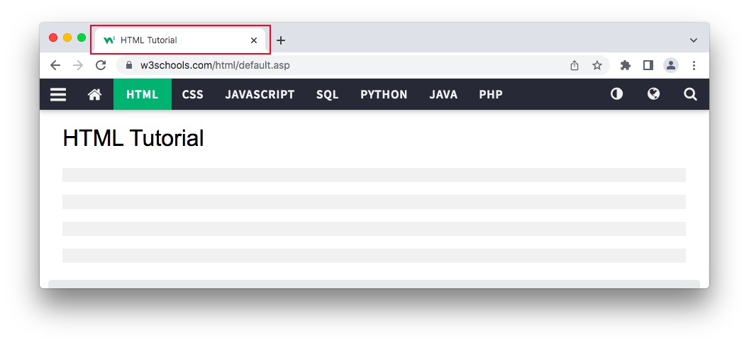

# **HTML Lists**

HTML lists allow web developers to group a set of related items in lists.

### **Example**

An unordered HTML list:

* Item
* Item
* Item
* Item

An ordered HTML list:

1. First item
2. Second item
3. Third item
4. Fourth item

## Unordered HTML List

An unordered list starts with the <ul> tag. Each list item starts with the <li> tag.

The list items will be marked with bullets (small black circles) by default:

### **Example**

<ul>  
  <li>Coffee</li>  
  <li>Tea</li>  
  <li>Milk</li>  
</ul>

## Ordered HTML List

An ordered list starts with the <ol> tag. Each list item starts with the <li> tag.

The list items will be marked with numbers by default:

### **Example**

<ol>  
  <li>Coffee</li>  
  <li>Tea</li>  
  <li>Milk</li>  
</ol>

## HTML Description Lists

HTML also supports description lists.

A description list is a list of terms, with a description of each term.

The <dl> tag defines the description list, the <dt> tag defines the term (name), and the <dd> tag describes each term:

### **Example**

<dl>  
  <dt>Coffee</dt>  
  <dd>- black hot drink</dd>  
  <dt>Milk</dt>  
  <dd>- white cold drink</dd>  
</dl>

## A Description List

Coffee

- black hot drink

Milk

- white cold drink

## HTML List Tags

|  |  |
| --- | --- |
| Tag | Description |
| [<ul>](https://www.w3schools.com/tags/tag_ul.asp) | Defines an unordered list |
| [<ol>](https://www.w3schools.com/tags/tag_ol.asp) | Defines an ordered list |
| [<li>](https://www.w3schools.com/tags/tag_li.asp) | Defines a list item |
| [<dl>](https://www.w3schools.com/tags/tag_dl.asp) | Defines a description list |
| [<dt>](https://www.w3schools.com/tags/tag_dt.asp) | Defines a term in a description list |
| [<dd>](https://www.w3schools.com/tags/tag_dd.asp) | Describes the term in a description list |

# **HTML Layout Elements and Techniques**

Websites often display content in multiple columns (like a magazine or a newspaper).

### **Example**

## Cities

* [London](javascript:void(0))
* [Paris](javascript:void(0))
* [Tokyo](javascript:void(0))

# **London**

London is the capital city of England. It is the most populous city in the United Kingdom, with a metropolitan area of over 13 million inhabitants.

Standing on the River Thames, London has been a major settlement for two millennia, its history going back to its founding by the Romans, who named it Londinium.

Footer

|  |  |
| --- | --- |
| HTML5 Semantic Elements | * <header> - Defines a header for a document or a section * <nav> - Defines a set of navigation links * <section> - Defines a section in a document * <article> - Defines independent, self-contained content * <aside> - Defines content aside from the content (like a sidebar) * <footer> - Defines a footer for a document or a section * <details> - Defines additional details that the user can open and close on demand * <summary> - Defines a heading for the <details> element |

## CSS Float Layout

It is common to do entire web layouts using the CSS float property. Float is easy to learn - you just need to remember how the float and clear properties work. **Disadvantages:** Floating elements are tied to the document flow, which may harm the flexibility

## CSS Flexbox Layout

Use of flexbox ensures that elements behave predictably when the page layout must accommodate different screen sizes and different display devices.

## HTML Iframe Syntax

The HTML <iframe> tag specifies an inline frame.

An inline frame is used to embed another document within the current HTML document.

### **Syntax**

<iframe src="*url*" title="description"></iframe>

**Tip:** It is a good practice to always include a title attribute for the <iframe>. This is used by screen readers to read out what the content of the iframe is.

## Iframe - Set Height and Width

Use the height and width attributes to specify the size of the iframe.

The height and width are specified in pixels by default:

### **Example**

<iframe src="demo_iframe.htm" height="200" width="300" title="Iframe Example"></iframe>

Or you can add the style attribute and use the CSS height and width properties:

### **Example**

<iframe src="demo_iframe.htm" style="height:200px;width:300px;" title="Iframe Example"></iframe>